Online Auctioning

User Manual

**Slippery Rock University**

Spring 2024

Jacob Johnston – jrj1014@sru.edu

Tiffany Morrow – tbm1005@sru.edu

Nicholas Vioral – ncv1005@sru.edu

Wolfgang Zoppelt – wsz1001@sru.edu

1. Introduction

This social marketplace application presents a variety of features from buying products, making deals and offers, to discussing trends, messaging friends and creating groups to share the experience. The idea and motivation behind this project originates from the need for a modern economy and community to share goods and services through. The goal of this manual is to inform future users and developers of the general flow and design of the product. To begin, see our Installation Manual in the documents folder. Once you have successfully installed the program, refer to the Login Manual to access our user accounts.

Welcome to Offerly! In the next few sections, we hope to assist you in navigating through the website and show you all we have to offer.

1. Index Page

The landing page for our website begins on the browsing page. Here, you can view some of the products for sale with information on the seller, price, and quantity available. You can navigate through the listings by page, set filters to view certain products, or type the name or keyword of a product you are looking for. For now, however, you will need to be signed in to view listings further. 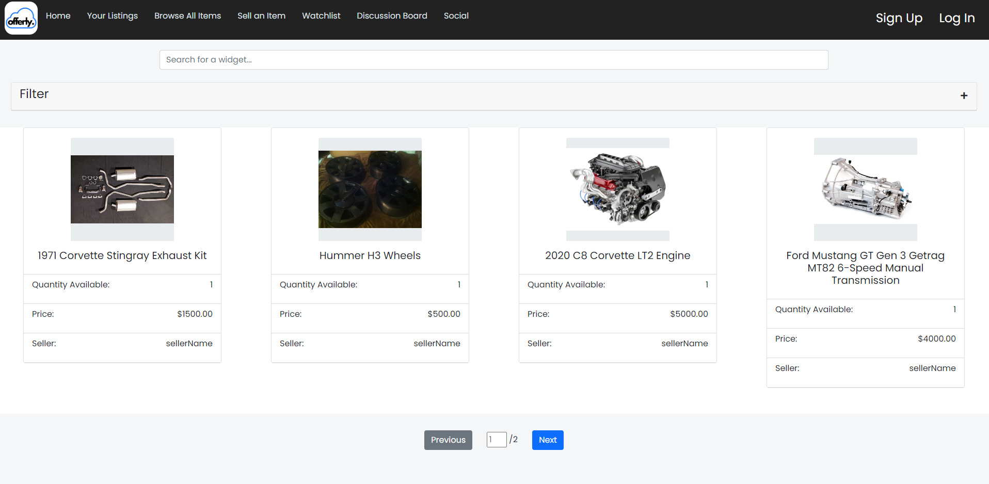

At the top of every page on our website, a navigation bar is present. From the nav bar you will see a list of activities and pages you can interact with. Some of the tabs will prompt you to sign in. You can sign up or sign in anytime.



Navigate to the Log In button now!

1. Login/ Sign-Up Page

The home tab, or login page allows you to sign in or create a new account. You can use one of the default accounts from the Login Manual or create a new user here. If you forgot any of your information, there are forms to help you get back on track.

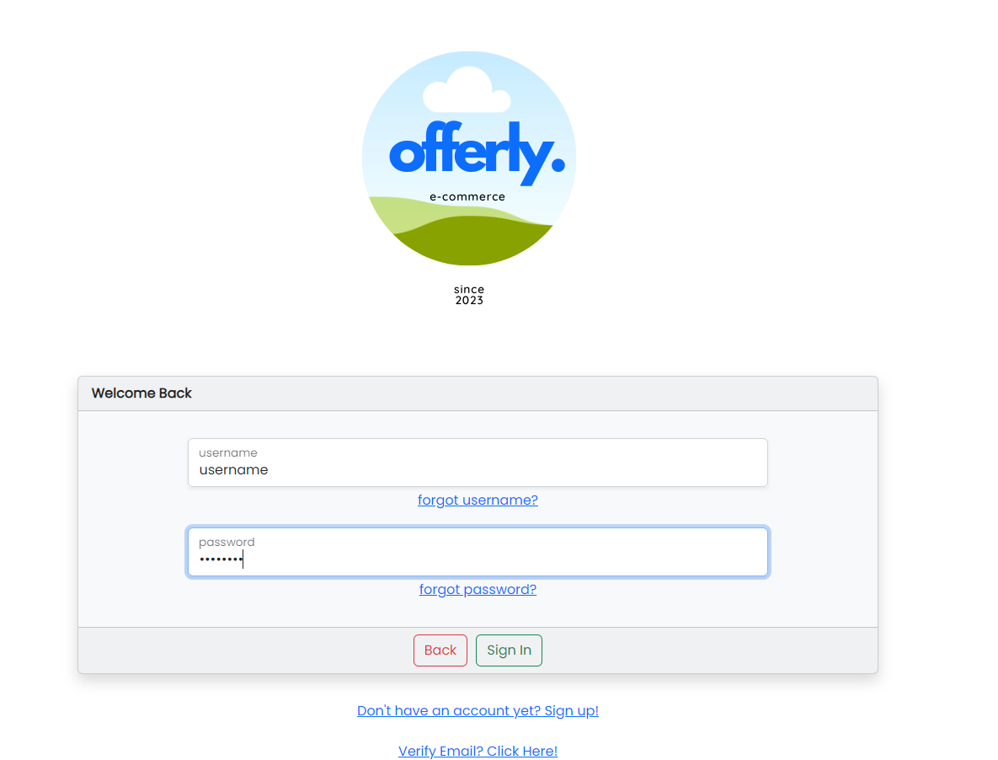

To create a new personal account, click the sign-up link at the bottom of the page.

You will need to make a username and password and enter in your personal information such as email, and phone number. There are security questions in place to help recover your account if you forget your login info. For security purposes, you will be asked to enter the CAPTCHA to verify your account. To do this, you must type the sequence of letters and numbers you see in the box above.

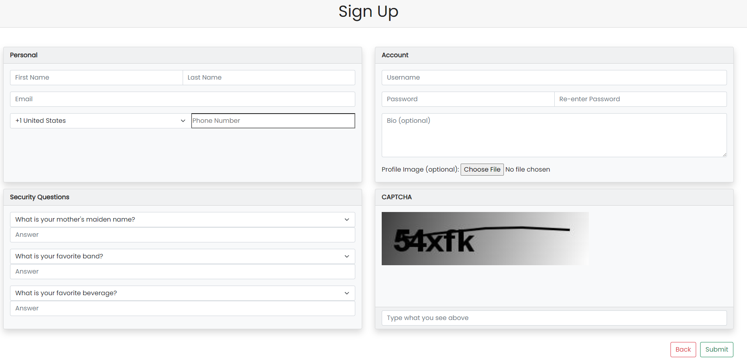

You may choose to enter in your address and payment information now but are not required to do so. However, if you want to make a purchase, that information will be needed. You can update your information anytime by clicking on your username located on the Nav Bar and selecting the appropriate category in the drop-down menu. You can also sign out from here.

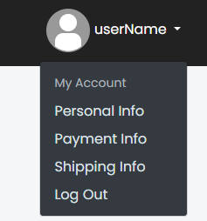

Once you make an account, you will be asked to verify your email. You can do this by signing into your personal email and clicking the link in the email from Offerly. You will need the verification code and the username associated with the account.

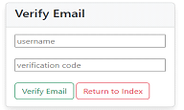

Once verified you are ready to start exploring all Offerly and all it has to offer!

1. Home Page

This page shows you basic information which will prove useful if you want to start buying and selling on Offerly! It displays purchase history, selling history and tracks information on listings currently being sold by you. Each listing contains a link to the item where you can view and make changes to your product and list any offers made to you. You can also see how popular the listing is with the corresponding view count.

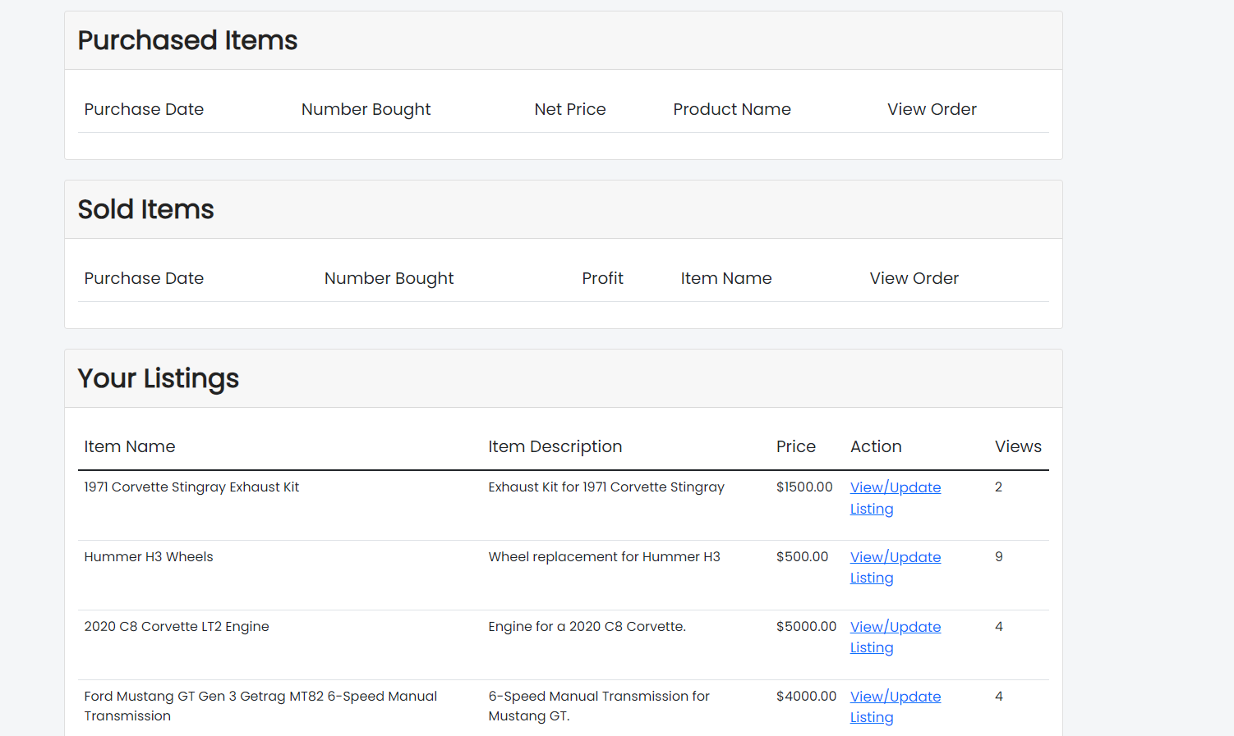

1. Your Listings Page

Once you become a renowned merchant on Offerly, managing all your listings might prove to be difficult. This webpage will help traverse your market with ease. This provides a more detailed account of all the products you are selling and have sold.

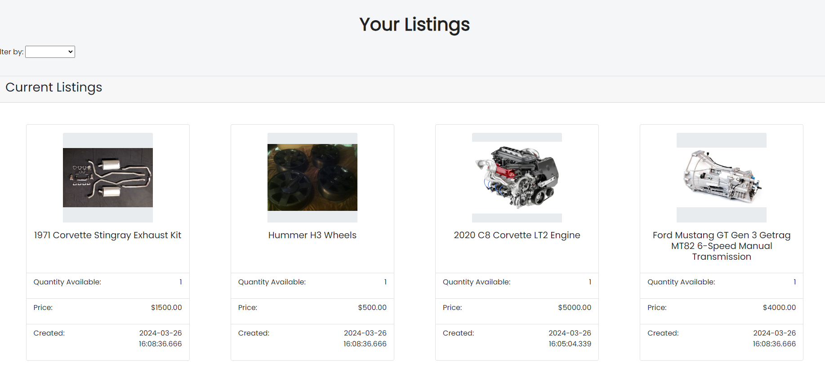

Clicking on each individual listing gives a view count, watchlist count and a way to navigate to the listing, to inform you of all the latest trends.

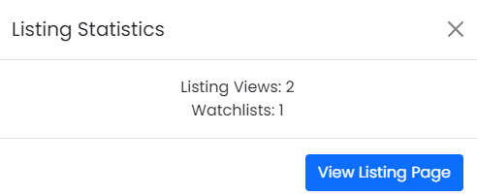

1. Market Listing Page

When viewing listings on the browse page, you can click on the listing icons to view more details on the corresponding listing. From that listing page, there are several options available to you.

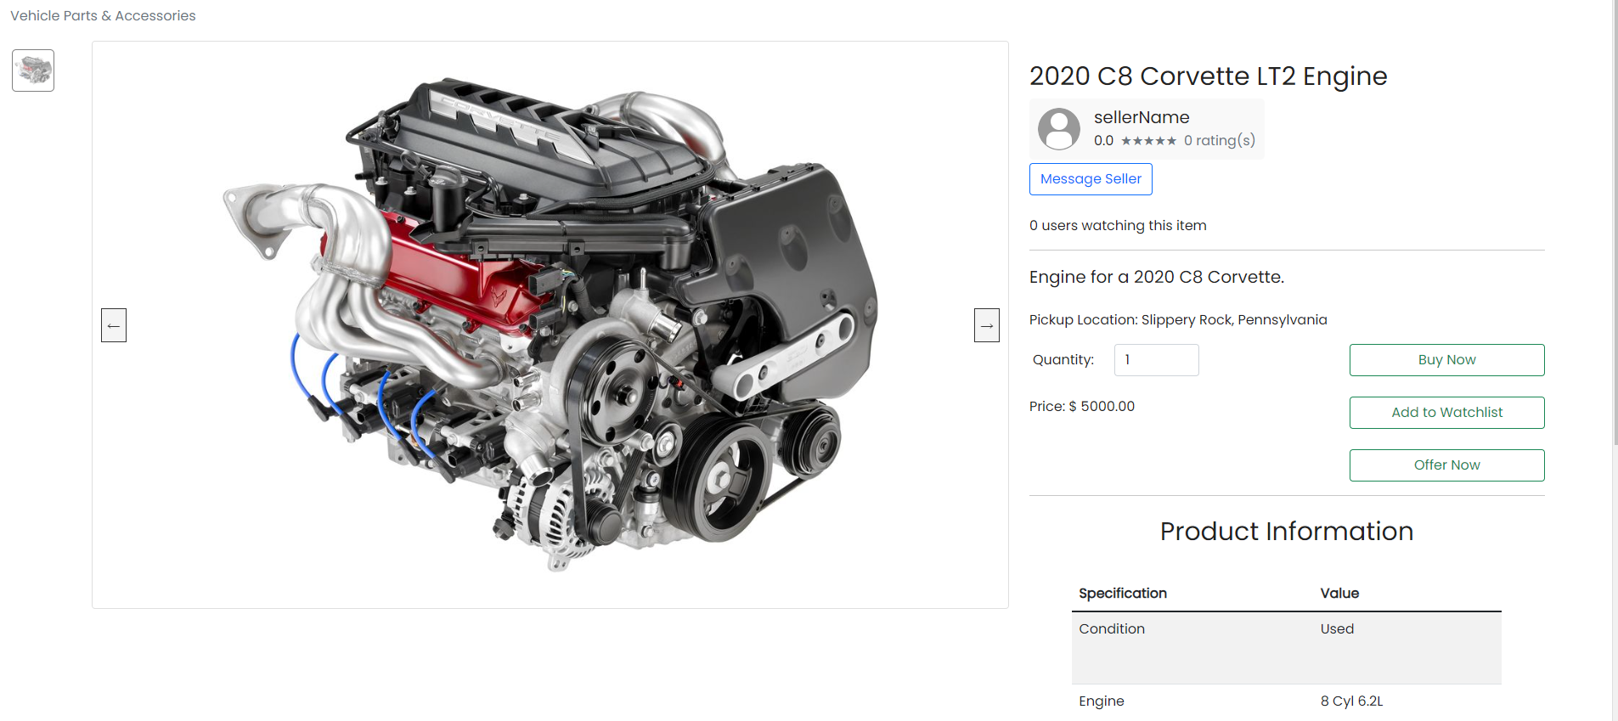

If you are interested in the product, you can view the seller's information, message them, add the item to your watchlist or make an offer. When you make an offer, a notification will be sent to the seller, you will be notified of the response. If an offer has been accepted for a product the listing will state that it's in a temporarily pending state. Only the user with an accepted offer may purchase the listing.

If you are selling a product, you can update/delete, or accept/reject offers on the listing page at any time. If you accept an offer, the listing page will be put into a temporary pending state. You will not be able to modify the listing during this time.

1. Sell an Item

To create a new listing and start selling products on Offerly, you can click on the "Sell an Item” tab on the Nav Bar. It will ask you for various inputs on the item being sold, some of which will be required in order to sell on the website. You can update the listing information at any time, but be sure to give it a name and include pictures!

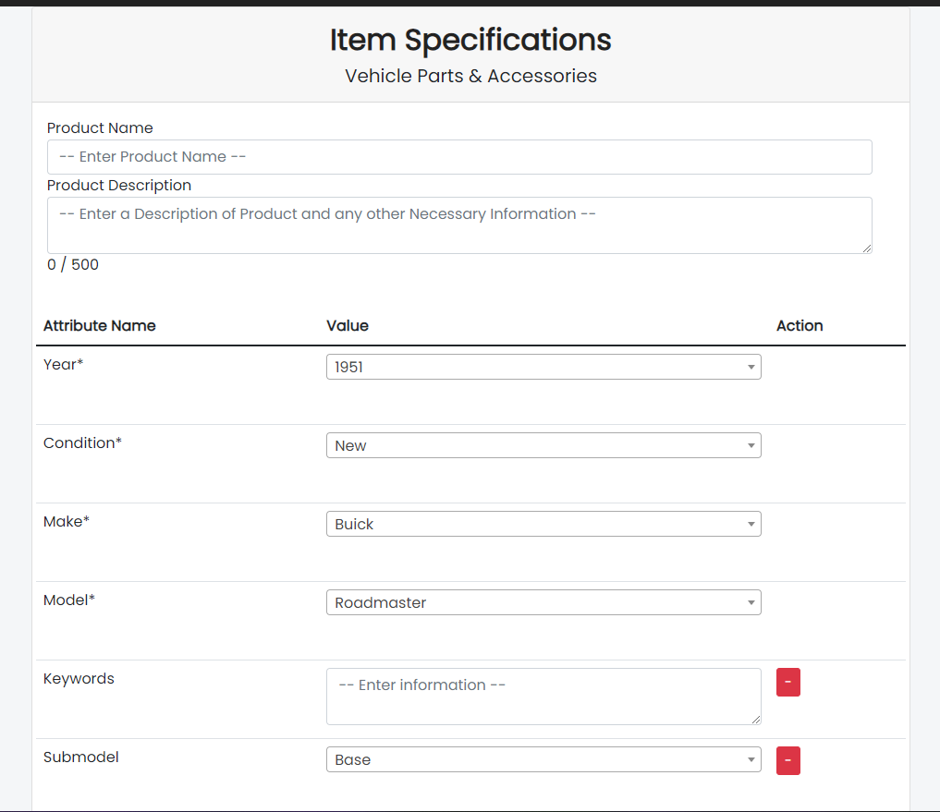

1. Watchlist

For user convenience, there is a watchlist tab where you can monitor any listings you may be interested in. It's a great way to keep tabs on any listings you may decide to purchase in the future.



1. Discussion Board

The Discussion Board tab is a great way to keep up with the Offerly community. There you can create and view posts on the latest fads. You can inquire about items, ask questions about products, alert users of suspicious accounts or products, and promote your own merchandise.

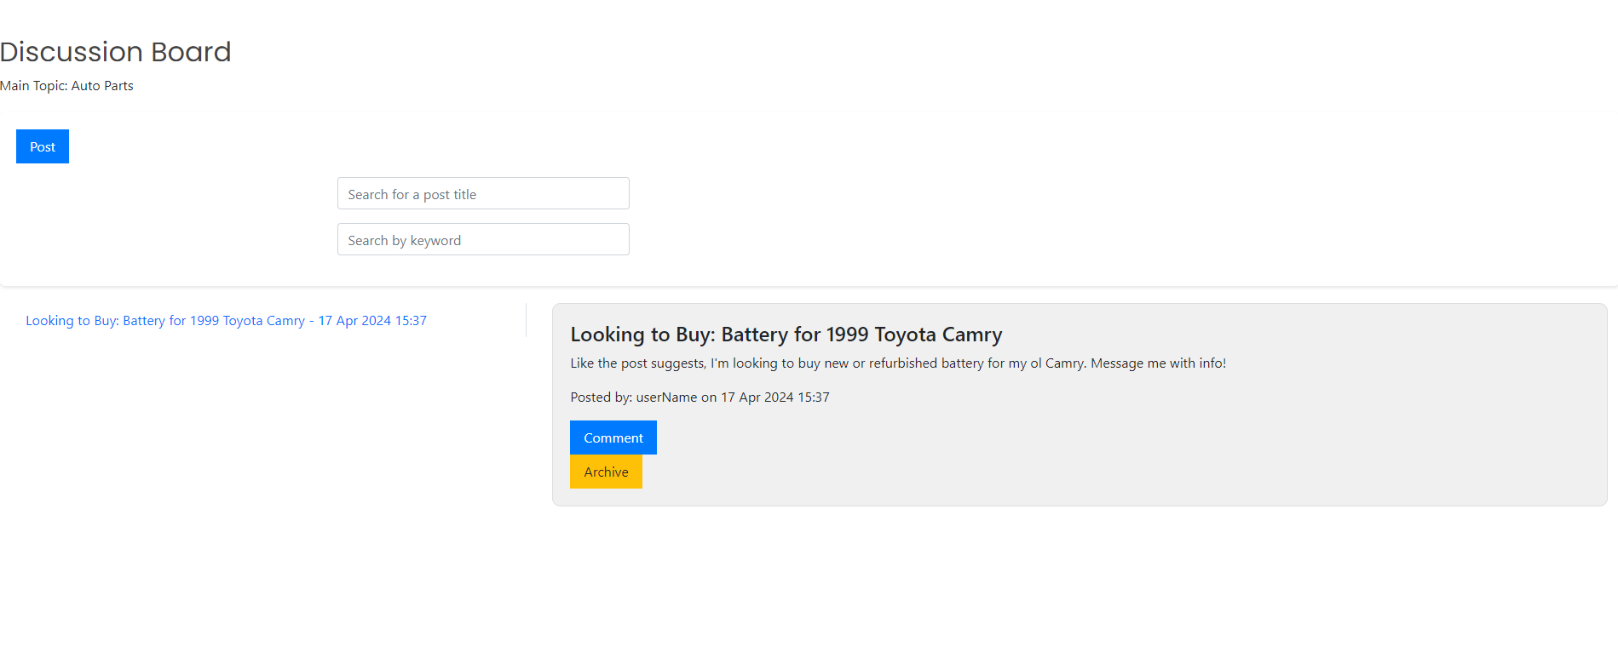 Administrators will have access to posts and monitor closely to make sure everyone feels safe and included in the community.

10) Social

The social tab on the nav bar keeps users notified about products and services and lets them connect with others through messaging and group chat. If you want to message sellers about their products or add a user as a friend, you can do so here.

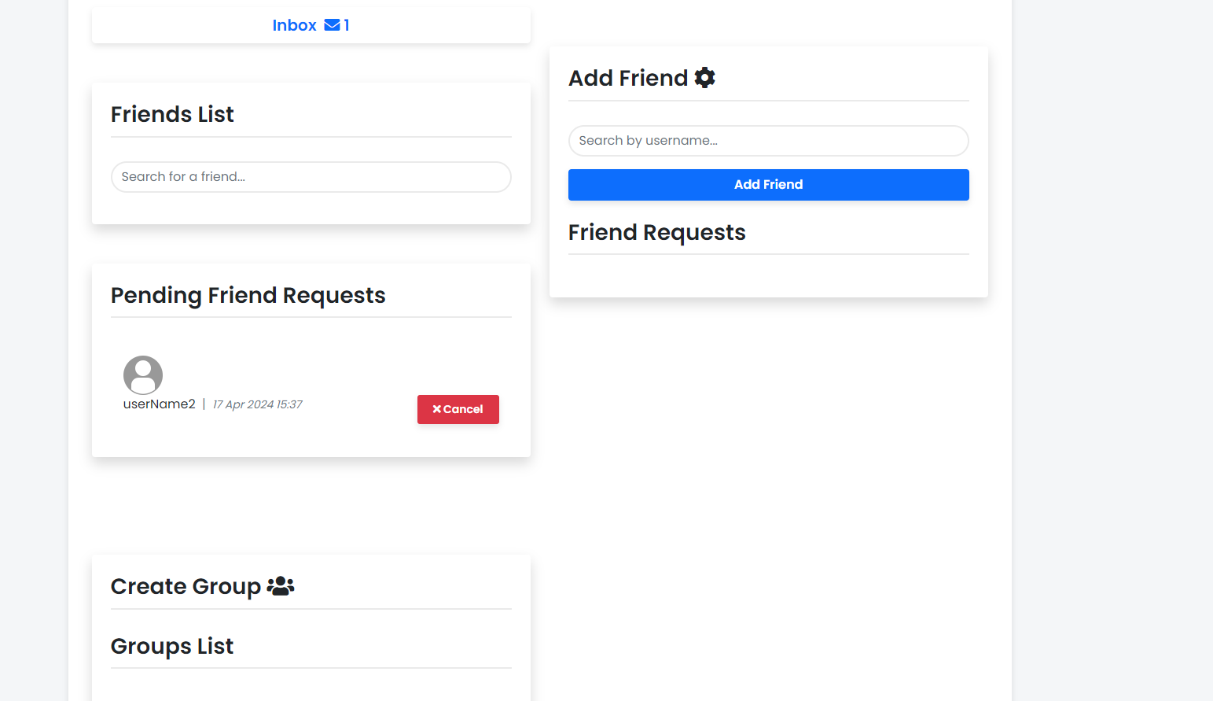

You can add friends to a group list to message multiple people at once, where you can further discuss products and goods.

11) Contact Forms

Lastly, users have access to a "Contact Us” tab on the nav bar. Here, they can directly contact Customer Service Representatives at Offerly to receive assistance or give feedback on any feature they desire.

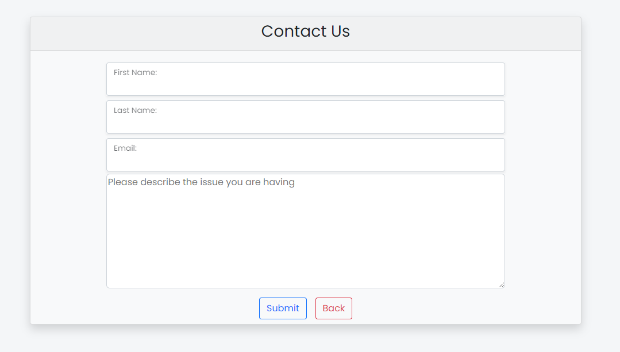

The forms will be sent to employees directly where they can be assigned and attended to in a timely manner.

12) Employee Page

Employers have access to the behind the scenes features of Offerly, such as a ticket system, user information, and detailed discussion/listing information.

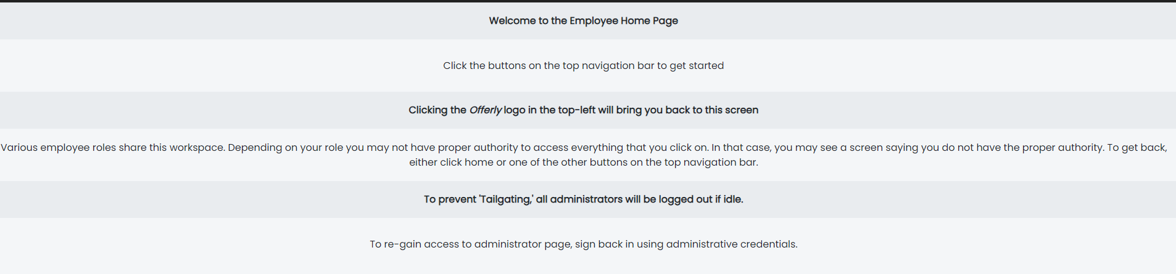

The employee landing page above gives some basic information.

13) Ticket Page

Employees can be assigned tickets based on their roles in the company. They may assign themselves tickets or the Administration can choose to assign tickets based on the criteria. Tickets may be passed along to other employees as needed and details can be recorded as well as status.

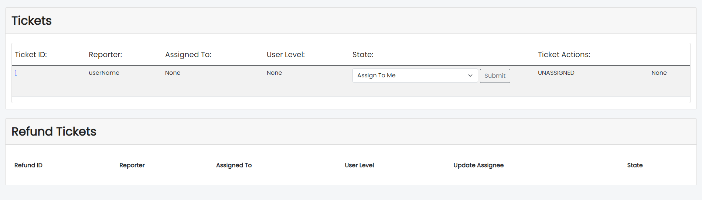

14) Administration Page

Only a super admin account can access and make changes to user accounts and listing accounts. For customer security and privacy concerns, some information cannot be altered.

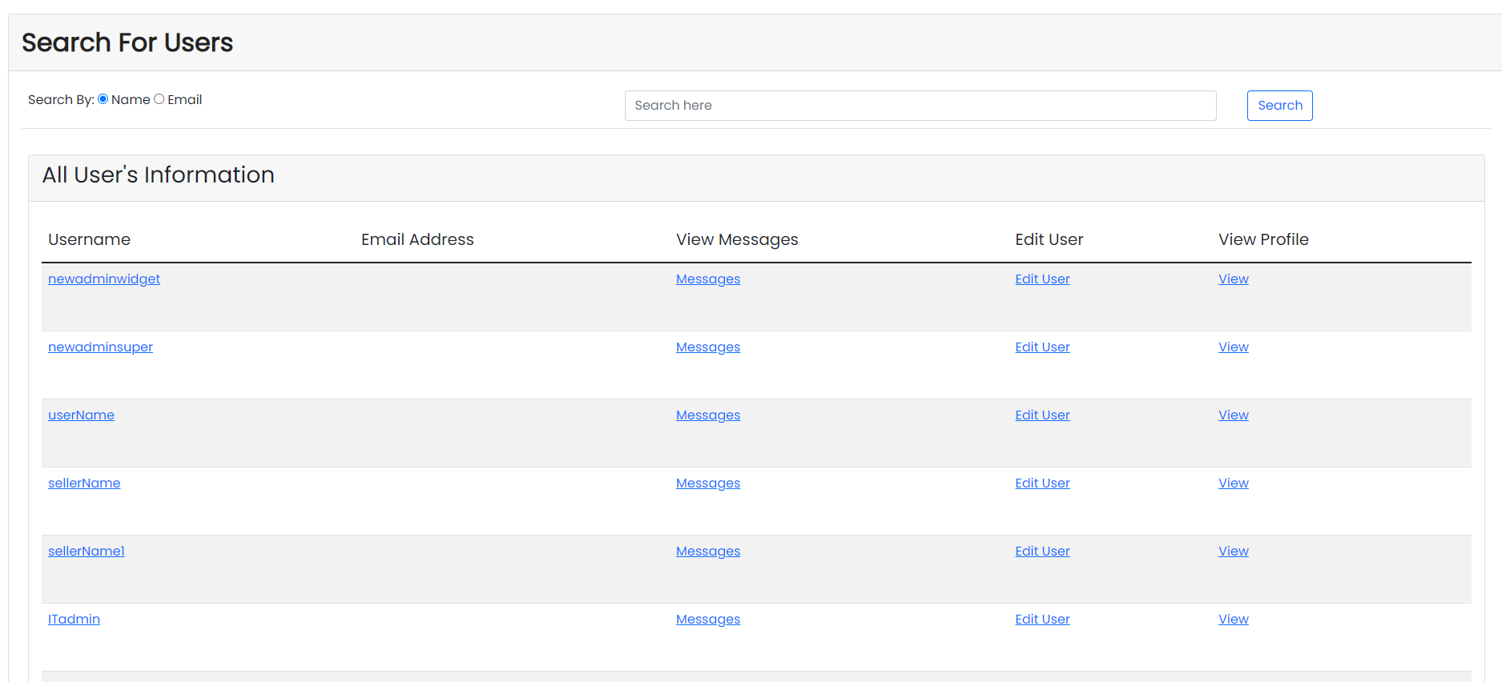

Conclusion

This concludes our tour of the program! This manual has been updated to keep users and developers up to date with the latest version of the project. We hope our efforts have been simple and informative. For more information, see some of the other manuals located in the documents folder.